Documentation

**Target Assessment Level**

The target assessment level for this work is 3.

**Specification**

What does the program do?

The program

1. reads data about runners’ race information from a file
2. allows user to search for runners based on their gender or age group; for each key (start of the word for their gender or age group), the program prints all those runners with the given key from fastest to slowest.

**Data format**

**Data file**

The input data text file consists of lines, each line containing



*  is a single word
*  is a single word
*  is a single word
*  is a single word with the ages it includes in brackets immediately after without a space in between
*  is a decimal number (double)

**User input**

User input consists of either (terminates program), or another string which is used to find runners whose gender or age group starts with .

**Correctness**

**Typical test case**

File runners.txt contains data from 7 runners. The following is a script obtained when running the program:

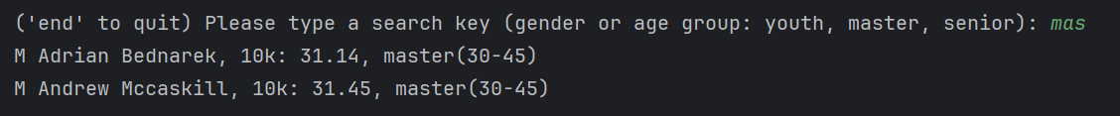

**Non-trivial algorithms**

**Selection sort**

Data is sorted in increasing order according to run times using selection sort.

**Searching**

Runners whose gender or age group contains the given key are searched for using sequential search.

**Arrays**

Runners are stored into an array for sorting and sequential search.

**Dynamic data structures**

* A list is used to read an unspecified amount of data from the data file.
* A list is also used to return an unspecified number of search results

**Classes**

A class is used to store the data of each runner.